  Logical Argument Essay  College Writing | DENASHA PATTERSON  June 29, 2019

Where Would We Be Without Them?
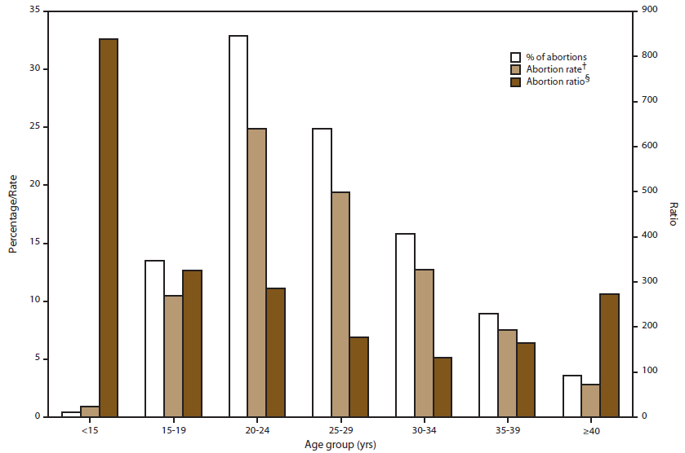
The first recorded evidence of induced abortion is from the Egyptian Ebers Papyrus in 1550 BCE. Many of the methods employed in early cultures were non-surgical. Physical activities like strenuous labor, climbing, paddling, weightlifting, or diving were a common technique. In the most recent report from the Centers for Disease Control and Prevention (CDC) the United States had approximately 638,169 reported abortions in 2015. Abortion is banned in 99 different countries, which mean more than half the countries of the world’s nations condemn the act. Some of these countries make exceptions in cases of incest, rape, deformities of the fetus or in cases where the mother's life is in danger, which I totally understand and believe to be logical exceptions. Outside of these exceptional circumstances, abortion is just morally wrong. It terminates a non-consenting life, causes physical and psychological damage, and eliminates potential societal contributions.
To understand abortion, you must know the history and how it became the controversial topic it is today. Abortion laws has been continuously changed throughout the history of the United States. When the first pilgrims came to North America they were still under British law and abortion was legal there during that time. Many places would even openly advertise this procedure and it was very common then. In the late 1800s majority of the states were passing anti-abortion laws for many reasons such as religious beliefs. Another one of the reasons included fears that the population would be dominated by the children of newly arriving immigrants, whose birth rates were higher than those of “native” Anglo-Saxon women.
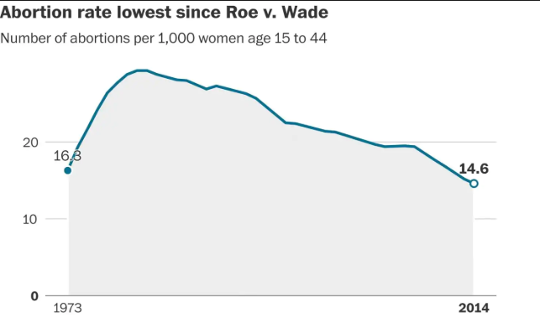
Fast forwarding to 1973, abortion was again made legal in the Supreme Court Case of Roe v. Wade. Just because abortion was not legal before 1973 doesn't mean women were not sneaking around to get them. These illegal abortions often resulted in injury to the woman and most times death not only for the unborn child, but for the mother as well. This Supreme Court Case made it legal for medical practitioners to perform abortions. The US Supreme Court had declared abortion to be a “fundamental right” guaranteed by the US Constitution. The 7-2 decision stated that the Constitution gives "a guarantee of certain areas or zones of privacy," and that "This right of privacy... is broad enough to encompass a woman's decision whether or not to terminate her pregnancy." Furthermore, the 14th Amendment bars states from depriving "any person of life, liberty, or property, without due process of law." (U.S. Constitution. Amend. XV, Sec. 1.) The Supreme Court overreached in Roe v. Wade when it excluded unborn children from the class of “persons.” (Roe v. Wade)
Life begins at conception, so unborn babies are human beings with a right to life. Upon fertilization, a human individual is created with a unique genetic identity that remains unchanged throughout his or her life. This individual has a fundamental right to life, which must be protected. Jerome Lejeune, the French geneticist who discovered the chromosome abnormality that causes Down syndrome, stated that "To accept the fact that after fertilization has taken place a new human has come into being is no longer a matter of taste or opinion… The human nature of the human being from conception to old age is not a metaphysical contention, it is plain experimental evidence." Termination of a non-consenting life is immoral and even the worst of criminals must withstand years on death row to eventually accept and receive death as a punishment. Medical personnel pronounce the death of an individual when their heart stops beating, which means without a heartbeat you aren’t living. So, when an embryo’s heart starts to beat, they are living human beings. On average, an unborn child's heart starts to beat at around 5 weeks. At this point your baby has already started developing its major organs (heart, stomach, liver, and kidneys. However, some might argue that at 5 weeks is when women usually find out they are pregnant, but again, their heart is still beating, and the unborn child still did not consent to the termination of THEIR life.
Yes, everyone’s body is different therefore there are different reactions to medical treatments. The range of possible complications may surprise you. Even the healthiest of individuals considering an abortion must educate themselves on the possible side effects. There are both physical and psychological consequences for those who decide to go through with this procedure. Once the procedure it is done it is irreversible.
During a first trimester abortion a woman is given a combination of pills called Methotrexate & Misoprostol (MTX). The combination of these 2 pills is used to stop the hormone progesterone which is vital in pregnancy. Eventually the baby dies and detaches from the uterus. That is when he or she will be vacuumed or scraped out the womb and the abortion is complete. Dilation and Evacuation (D&E) is the type of abortion performed after 12 weeks. The abortionist will dilate your cervix (the opening of your uterus) then use their instruments to dismember and extract the baby piece by piece. They might then go in with a scraping device to ensure all parts of the deceased baby were removed and then your abortion is complete. Sounds horrible right? Seventeen percent of women participating in a study on the effects of abortion reported they have "experienced physical complications (e.g., abnormal bleeding or pelvic infection) since their abortion." Based on reported abortion statistics, this represents 200,000 women annually experiencing physical complications after an abortion. (Brenda Major, Archives of General Psychology, 2000) Incomplete abortions, where parts of the fetus are left behind, can lead to infections and bleeding. Punctures or tearing of the uterus and/or cervix due to the materials used during the abortion may cause difficulties in later pregnancies. Most women feel an extreme relief after getting out an unwanted pregnancy and don’t feel the mental effects until weeks or months after. Some woman reported feeling depression, grief and emotional coldness. It is most common in young teens who have an abortion to commit suicide. An analysis of nearly 15 years of published research found "women who had undergone an abortion experienced an 81 percent increased risk of mental health problems, and nearly 10 percent of the incidence of mental health problems was shown to be directly attributable to abortion." (Priscilla K. Coleman, British Journal of Psychiatry, 2011) The grass isn’t always greener on the other side. (National Abortion Foundation) Abortion is not without risk to our bodies, our minds and our emotions.
Abortion eliminates the potential societal contributions of a future human being. According to Heisman Trophy-winning football player Tim Tebow, "the reason I'm here" is because his mother ignored the advice of doctors who recommended an abortion. Think of your favorite music artist. Could you even imagine your favorite playlist without them? Or playing your favorite jam and it’s not them? Yeah. I’m pretty sure that would suck. Well, it has also been reported that the mothers of entertainers Celine Dion, Cher, and Justin Bieber were either advised to have abortions or were considering the procedure but chose to give birth to their babies (our favorites) instead. Where would education be without Albert Einstein? Where would technology be without Bill Gates? Where would your family be without you? Every human being can make a huge difference whether you know that or not. And you will never know if you decide to end that human’s life without consent. True, most babies delivered from abortion are not celebrities or creative geniuses. But they become adult children, moms and dads, police officers, surgeons, repair our furnaces, deliver our mail, and roof our houses. Human potential is amazing, human life is precious.
As a new mother I absolutely know how hard pregnancy can be and the thoughts that go through our heads when we first found out something so unexpected. But hearing my daughter’s heartbeat and seeing her little arms and legs move around as opposed to seeing a still dead little body that’s not moving was one of the most amazing things I’ve experienced in my whole life. If you choose not to experience something similar you would just be terminating a life without them having a say so, causing physical and psychological issues for the mother in the long run, and eliminating potential societal contributions. Everyone should have a chance at life no matter how they were brought into this world.

Assignment Questions
- What are the 1-2 main concepts you learned in this module?
Two main concepts that I learned in this module were the claims: claims of fact, claims of policy, and claims of value. I also learned STAR (Sufficiency, Typicality, Accuracy, and Relevance) which is one such technique for assessing whether an argument has enough depth and clarity.
- What challenged you in learning the concepts and applying them to create your essay? What might you do in the next module to lessen the challenge?
What challenged me was making sure my information was relevant. I feel as if I was giving a lot of evidence, but it ended up supporting something different which caused me to revise a lot afterwards. In my next module, I will try my best to getting more stable supporting topics that would be not necessarily easy to support, but something that has more concrete information that I can support with concrete evidence.
- Identify a different writing situation (academic or non-academic) and explain how you might apply a concept learned in this module to that situation.
I can apply the concept of pathos, logos and/or ethos when I have to write an advertisement T.V. skit in my other class.

List of Sources
Abshire, Mark. “Abortion Pills .” What You Need To Know, Abortion Procedures, 3 May 2016, www.abortionprocedures.com/abortion-pill/.
Bach, Melissa. “5 Weeks Pregnant.” Pregnancy Week-by-Week, The Bump, 30 Dec. 2016, www.thebump.com/pregnancy-week-by-week/5-weeks-pregnant.
Best_Schools. “15 Logical Fallacies You Should Know Before Getting Into a Debate.” TheBestSchools.org, 25 Feb. 2019, thebestschools.org/magazine/15-logical-fallacies-know/.
Coolidge, Ardee. “Why Abortion and Teen Suicide Are Inexorably Linked.” Pregnancy Centers, CareNet, 13 July 2017, www.care-net.org/abundant-life-blog/why-abortion-and-teen-suicide-are-inexorably-linked.
Eric Pace, “Dr. Jerome Lejeune Dies at 67; Found Cause of Down Syndrome,” 12 Apr. 1994, https://www.nytimes.com/1994/04/12/obituaries/dr-jerome-lejeune-dies-at-67-found-cause-of-down-syndrome.html
Mittleberg, Mark. Questions Christians Hope No One Will Ask. Tyndale House Publishers, 2011.
Moore, Thomas. “When Can I Hear My Baby's Heartbeat?” BabyCenter, Baby Center, May 2019, www.babycenter.com/404_when-can-i-hear-my-babys-heartbeat_10349811.bc.
Pazol, Karen. “Abortion Surveillance - United States, 2015 | MMWR.” Centers for Disease Control and Prevention, CDCP, 23 Nov. 2018, www.cdc.gov/mmwr/volumes/67/ss/ss6713a1.htm.
Pauker, Paul. “The Case Against Roe v. Wade and Planned Parenthood v. Casey.” LifeNews.com, 5 June 2011, www.lifenews.com/2011/06/01/the-case-against-roe-v-wade-and-planned-parenthood-v-casey/.
Robinson, Dana. “The Emotions During Pregnancy.” Pregnancy Birth and Baby, Health Direct, Aug. 2017, www.pregnancybirthbaby.org.au/.

